Nicholas Kamper and Eric Henderson

CSSE463 – Image Recognition

Lab 7 – Principle Component Analysis

In this lab, we implemented the PCA algorithm and used it to compute the top eigen images and reconstructions of those images from a large set of webcam data.

# Procedure and Results

We implemented the PCA algorithm in MATLAB and ran it over the #82 data set, as obtained from <http://www.cse.wustl.edu/~jacobsn/projects/webcam_dataset/data/82_week.tgz>.

We stored all of these images into a matrix, with one RGB image in each column vector and centered the data on the mean image. Each image was scaled by a factor of 1/4th. We computed the covariance matrix using $N*N^{T}$, as discussed in class, and then found the eigenvalues and eigenvectors using MATLAB’s eigs() function.

For the #82 data set, we found the following eigenvalues:

$5.2631*{10}^{10}$

$0.0736*{10}^{10}$

$0.0523*{10}^{10}$

$0.0385*{10}^{10}$

$0.0290*{10}^{10}$

$0.0110*{10}^{10}$

$0.0070*{10}^{10}$

* 
* 0.0063 ${10}^{10}$

$0.0055*{10}^{10}$

*
* 0.0035 ${10}^{10}$

*

As expected, the first eigenvalue is large and then the subsequent values trail off fairly quickly.

We reshaped and scaled the first eigenvectors to generate three eigenimages for the data set (Figures 1, 2, and 3).

Figure – Eigenimage #1

Figure

With the eigenvectors, we were then able to reconstruct two of the images by projecting the images onto the eigenspace. These images can be seen in Figures 4 and 5.

Figure – Eigenimage #3

Figure 2 – Eigenimage #2



Figure 5 – Image #152, reconstructed with $C_{1}=2.0253*10^{4},C_{2}=-932, C_{3}=-3.2767*10^{3}$

Figure – Image #40, reconstructed with $C_{1}=1.9892*10^{4}, C_{2}= -102, C_{3}=-1.686*10^{3}$

Finally, we plotted the values of $C_{1}$ over the images.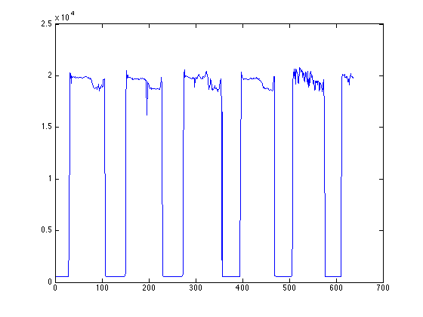

As one could possibly expect, these values tend to correspond with the time of day – lower values mean that it is darker outside, while higher values correspond with daylight.